**Assignment 2 Social Network**

**Class: ITC322**

**Student Name: Aaron Brody**

**StudentID:** **11574516**

**Session:201830**

Run program from console.

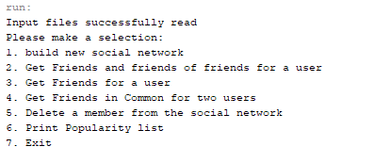+

Result the social network will confirm it is built

Press 2 and press enter, then type Superman and press enter

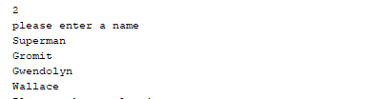

Result: Gromit, Gwendolyn and Wallace are returned.

Press 3 and press enter then type Superman and press enter

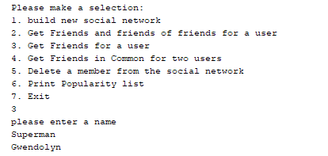

Press 4 then press enter, then type Superman then press enter then type Wallace then press enter

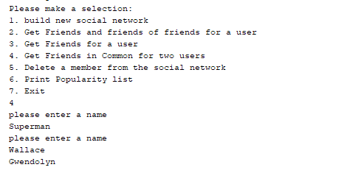

Press 6 to print popularity report

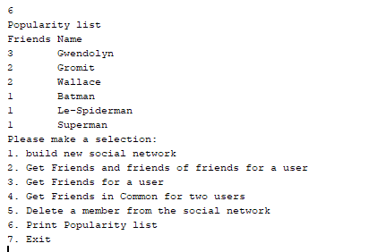

Press 5 type Gromit then press enter, then type 1 and press enter

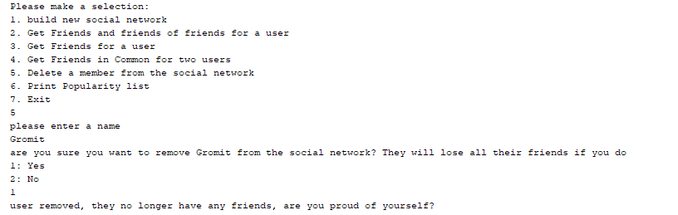

Press 6 and press enter Wallace is removed.

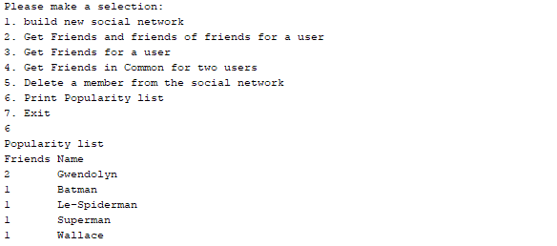

Press 7 and then press enter to exit.

